Overview of Project

The project is to figure out how different Kickstarter campaigns compared in relation to their launch dates and their funding goals. I used the Kickstarter dataset to create an analysis with diagrams for finding trends in campaign outcomes based on their launch dates and their funding goals.

Purpose

The purpose of this project is to find trends in the data as well as to discover the secret to a successful Kickstarter, with a focus on assessing whether launch date and funding goal are associated with project success.

Analysis and Challenges

Initial analysis of the data has shown that success rates of the Kickstarters is seasonal, with a higher rate of success in the summer and lower rates of success in the winter. Difficulties that I faced when working on the project were few. However, I would say the greatest challenge was finding an appropriate way to represent the data while ignoring outliers. Such as this analysis shows a trend in that Kickstarter campaigns had a higher rate of success during the seasonal periods of summer and a lower chance of success in the winter.

Analysis of Outcomes Based on Launch Date

Analysis of the outcomes based on the launch date showed that Kickstarters had the highest rate of success in May, with a 67% success rate. See the blue line in the chart below, while the chart uses the counts of outcome, I converted it to percentages for easier explanation and legibility.

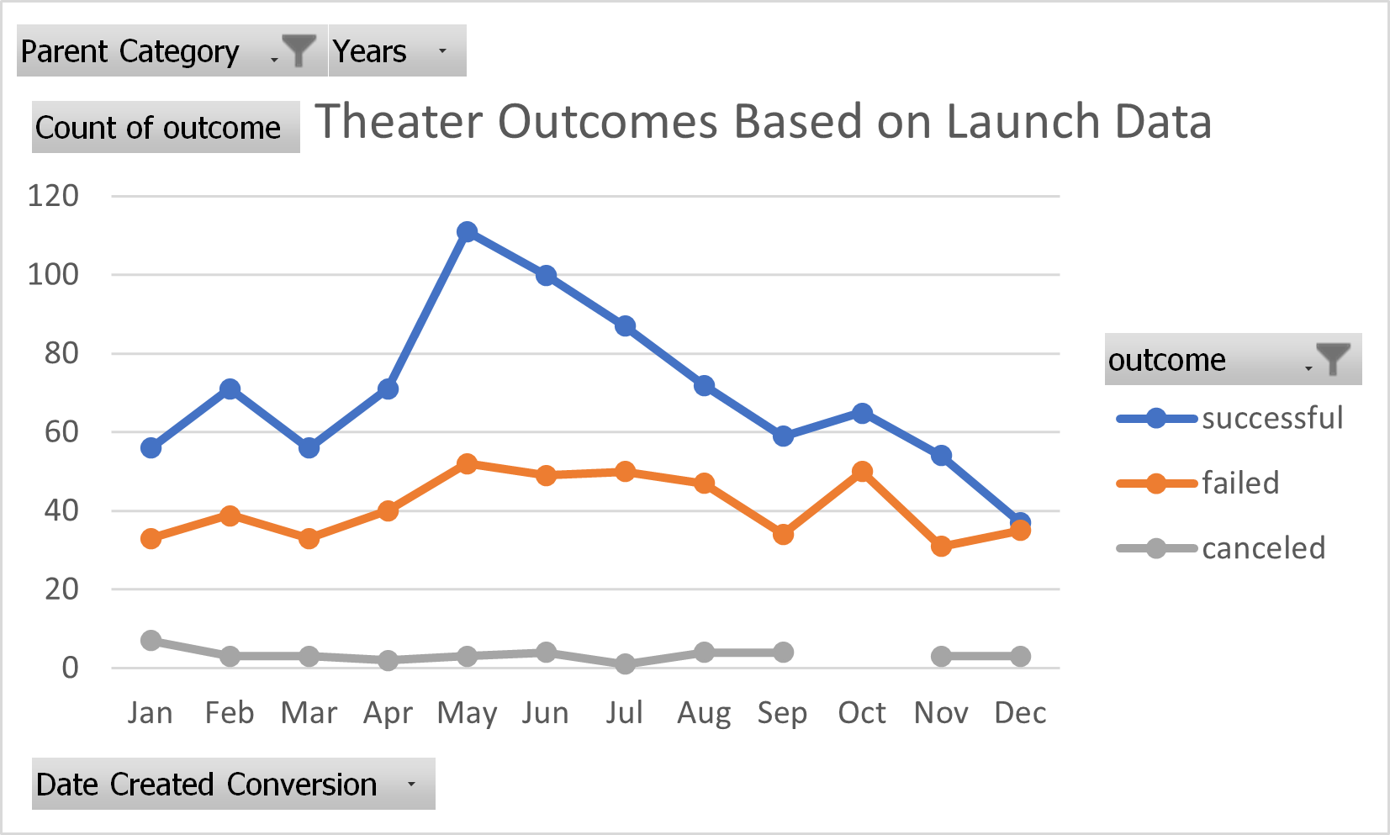

The following months of June and July also displayed strong degrees of success with a success rate of 65% in June and a 63% success rate in July. On the other hand, the month with the lowest number of successful campaigns took place in December with a success rate of 49%. Cancelations did not vary each month and had little to no effect on success rate.

Analysis of Outcomes Based on Goals

A further analysis of the outcomes based on goals showed a different trend. The other things I’m noticing here is that for the middle range, there is not a lot of variability – about 50% success. When a Kickstarter campaign had a goal amount of Less than $1,000, the success rate was 67%, when the goal amount was between $1,000 to $4,999, the success rate was 71%. As depicted by the blue line in the chart below:

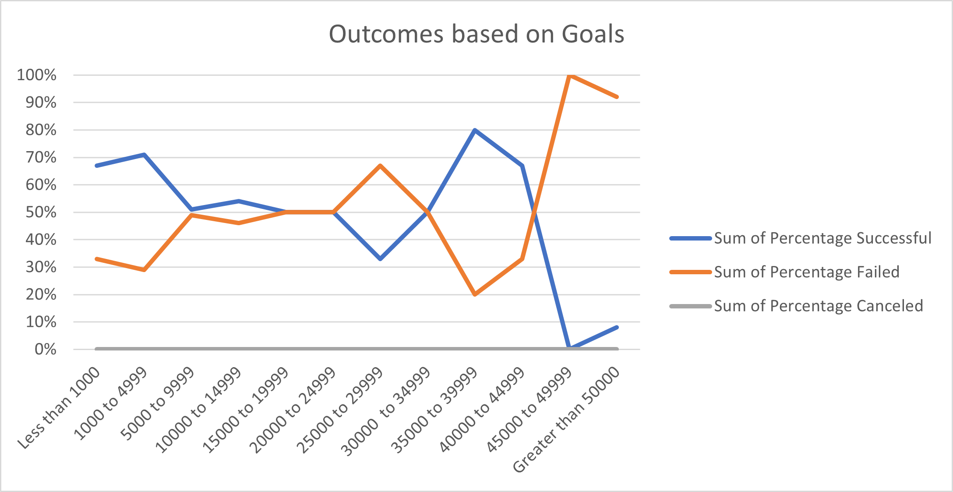

On the opposite end, as the goal amount increased the success rate decreased dramatically with a complete failure of all Kickstarters with goal amounts between $45,000 to $49,999. The only exception to this trend is the Kickstarters that had a goal amount of $35,000 to $39,999, which had a success rate of 80%. This is because there was a small number of campaigns in that goal range and most of them were successful. Overall analysis of this trend showed that a lower goal amount increased the chances of success and any goal amount above $45,000 had a substantial chance of failing.

Challenges and Difficulties Encountered

A few difficulties I noticed were the small dataset The results of the analysis of the project have shown a few interesting points. The graph that depicts the outcomes based on launch date has shown that the success rate of Kickstarter campaigns is seasonal, with a higher rate of success in the summer months and a lower chance of success in the winter months. While the graph that depicts the outcomes based on goals shows a different trend. Kickstarter campaigns had a higher chance of success when the goal amounts were below $5,000 and an extremely lower chance of success when the goal amounts were over $45,000. I believe the limitations of the dataset are that I can see a trend within the data but lack the information to verify my speculations. Such as more data to find a reason behind the seasonal dependance on success rate.

Out of the available graphs and charts, I think that a line chart depicting successful Kickstarter campaigns based on each year would be highly interesting. Such as this one:

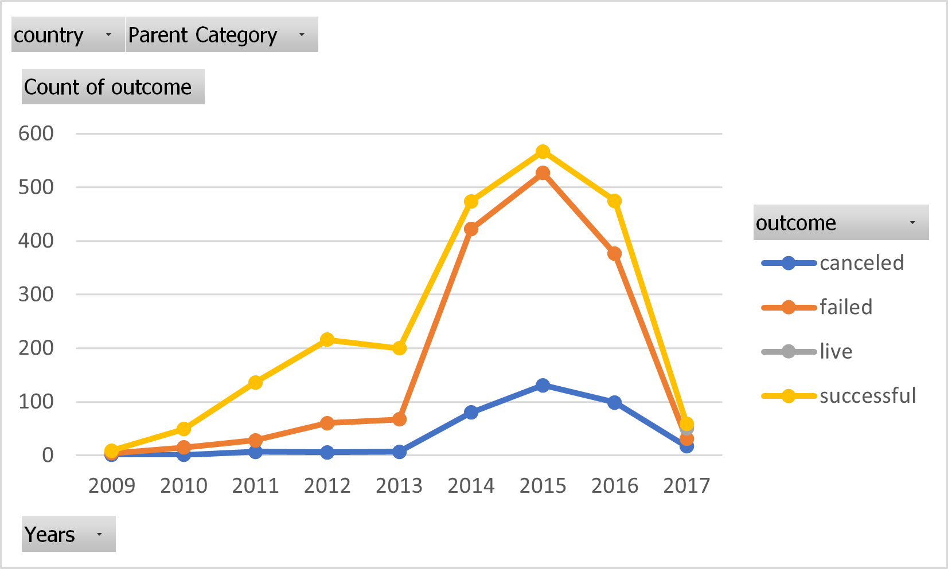

Results

Overall analysis of the data shows that if you want to have the highest chance of a successful Kickstarter campaign, launch the campaign in May with a goal under $5,000. If you desired to start a Kickstarter campaign with a higher goal, it would be a high-risk, high-reward scenario.

